# **KIVAPELI GAME STUDIO COMPANY**

# **Final Report**

Creating Entertaining Values for people in their free time

Group number 15 members

Nguyen Xuan Binh (887799)

Tien Minh Tran (890210)

Kien Nguyen (897954)

Chian Chen (906557)

# Introduction to Industrial Engineering and Management

# Professors Mikael Öhman, Paul Lillrank

# September 22nd 2020

Table of Contents

I. Business Plan & Marketing 4

1. The Business Model 4

a. Name & Business Idea 4

b. Mission & Vision 4

c. Product Offering 4

d. Business Model Canvas 5

2. The Business Environments 5

a. current competitive situation 5

b. PESTEL analysis 6

c. Porter’s Five Forces framework 6

d. Current situation of large competitors: 7

3. Marketing Strategy & Positioning 7

a. STP-Analysis 7

b. The Marketing Mix 8

c. How we stand out: Porter’s Generic Strategies framework 9

II. Product system & Capacity 10

1. Planning of production system 10

a. The 4V model (Volume, Variety, Variation, Visibility) 10

b. Type of production process 10

c. Stages in production process (pipeline) [5] 11

d. Flow units, transformation and value 11

e. Resources in the production phases 11

2. capacity 12

a. Capacity of our production system 12

b. Utilization rate of resources 12

c. Our potential bottleneck 13

III. Materials, production flows and waste 13

1. Material flows & facilities 13

a. Type of layout in our production system 13

b. Process steps alignment in our production system 14

c. Process flow chart 15

2. production flow 16

a. Push or pull control? 16

b. Throughput time and flow efficiency 16

3. Minimizing waste 17

a. Deviation of quality 17

b. Ways to reduce deviation of quality 17

c. Minimizing waste 17

IV. Operations, procurement, supply chain & demand Assessment 18

1. Focus of operations & procurement 18

a. Core capabilities 18

b. Outsourced activities 19

c. Procurement 19

d. Parts of our supply chain 19

2. Demand assessment 21

a. Fluctuation in demand 21

b. Withstanding fluctuations in demand 21

c. Demand estimation 22

V. Project network & risks 23

1. Project network 23

a. Task Network 23

b. Flexibility in our project network 23

c. The critical path 24

2. Risks 24

a. Categories of risks 24

b. Our preparation for risks 25

VI. Financial statements 26

1. Financial statements 26

2. Assessment of profitability, liquidity and solvency 26

3. Investments 26

VII. References 27

# I. Business Plan & Marketing

## 1. The Business Model

### a. Name & Business Idea

- Name of our company: Kivapeli Studio. “Kiva” means “Nice” and “peli” means “Game” in Finnish. Together they mean “Nice game”.

- Business Idea: We will create mobile games related to the Finnish culture in particular and Nordic culture in general. Our game genre will be interactive adventure type, where characters will be developed by player’s choice throughout the game. The theme will be based on Norse mythology and Finnish Kalevala. We want to explore building games related to national culture, mythology and history. If this genre proves to be successful, we will expand to make games based on themes of other nations (Romance of three Kingdoms – China, Vedic literature – India, Greek mythology, US and Roman empire history timeline), covering players in many targeted different nations.

- Reason for this business idea: national culture is not subject to copyright problems, can easily target players and has no licensing fee

- Our company will be a mid-size game studio with around 10 personnel in three major roles: artists, designers and developers. Our main platforms will be mobile phones and iPad.

### b. Mission & Vision

- Mission: “To introduce a unique and “torilla tavataan” culture to people worldwide”, that is, to unite people together and have fun.

- Vision:

+ “We are creating a long-lasting brand known for artistic and high-quality interactive adventure games.”

+ “We provide a workspace that embrace creativity and quality-focused products”

+ “We aim to promote cultural understanding and integration to people worldwide”

### c. Product Offering

- Characters and timeline-based theme adventure mobile games with aesthetic design and engaging storyline, which are based on national identity.

- Features:

+ Adventure Mode: Players will follow a fixed timeline in the game and acquire characters and items. Dialogues are based on real details from the mythology/literature.

+ Quest Mode: Players will participate in several events to acquire rare items

+ Direct combat Mode: Players can join in direct live fighting matches with another

+ Environment and Characters: we will constantly improve the appearance and design of characters and the virtual world in the games, which is central to our games’ immersive value.

### d. Business Model Canvas

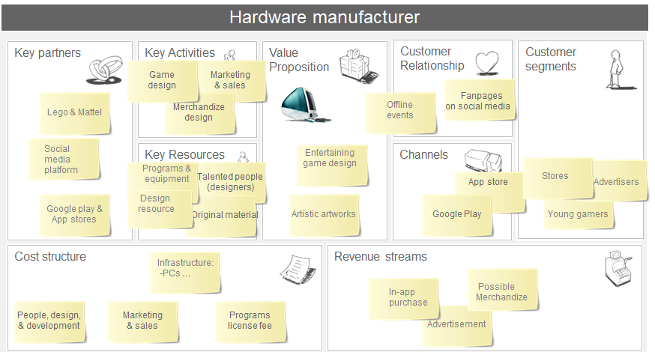

## 2. The Business Environments

### a. current competitive situation

- Direct competitors: Large and well-known franchise like Rovio Entertainment, Supercell, Remedy Entertainment, Sulake, RedLynx, Frozenbyte and Housemarque; all are based in Finland and are worldwide famous game brands and there are also hundred other small game start-ups in Uusimaa region of Finland.

=> It is extremely competitive for game start-ups in Finland.

- Indirect competitors: people have many ways to be entertained in their free time: social media, TV’s channels, Netflix and entertaining public places.

- Current demand for games in 2020:

+ The global gaming market was valued at USD 151.55 billion in 2019 and will reach a value of USD 256.97 billion by 2025, registering a compound annua growth rate of 9.17% over 2020 – 2025 [1]

- Increasing demand for cloud gaming.

- Increasing presence of E-sport.

- The Covid-19 Pandemic results in surges in game sales.

### b. PESTEL analysis

|  |  |  |  |  |  |
| --- | --- | --- | --- | --- | --- |
| **Political** | **Economic** | **Social** | **Technological** | **Environmental** | **Legal** |
| ➤Publishing  permission by the government  ➤Revenue taxations  ➤ Political censorship | ➤ Market growth rate of industry: 9,3% [2]  ➤Decreasing in material costs | ➤More open about playing games  ➤More time for pleasure activities  ➤Frequently variable appetites | ➤Different operating systems adaptation  ➤E-commerce on social media platforms  ➤Maintenance, debugging, upgrading app | ➤Electricity usage  ➤Non recycled hardware’s materials | ➤Content restriction in different cultures, religions  ➤Age restriction |

### C. Porter’s Five Forces framework

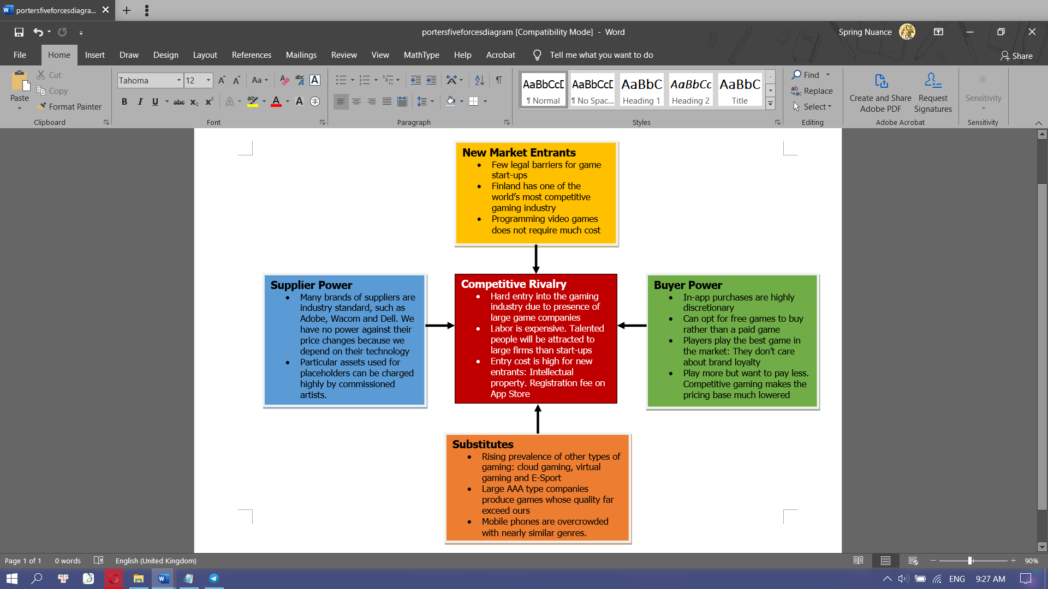

### D. Current situation of large competitors:

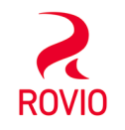⟹ Annual revenue constantly(>$280M) since 2017 and last month revenue > $6M [3]

⟹ Approximate 9 million daily users [4]

⟹ Launched new products like Movies (2016 and 2019), Games (Angry Bird Dream Blast (2018), Sugar Blast (2019), Small Town Murder (2019))

⟹ Monthly revenue >$100K

⟹ Forming a long partnership with Supercell in 2016

⟹ Launched new Games: Bad Land Brawl (2018), Rumble Stars Football (2019), Rumble Hockey (2020)

**=>** EA Track Twenty in Helsinki: income of game SimCity is 2 million dollars

=> Total downloads of SimCity over 300000 times [5]

=> Remedy Entertainment: 17.8 million euros revenue in 2019

=> Create their own fictional franchise that returns millions of copies sold

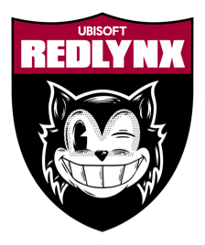

=> Red Lynx: 25 total million downloads on mobile platform across 48 countries

=> Revenue hits at $40.60 Million

## 3. MArketing Strategy & Positioning

### a. STP-Analysis

|  |  |
| --- | --- |
| **Segmentation** | + Intensity of playing: Extreme multi-gamers, frequent gamers, light gamers and time-killer gamers + Devices: mobile, PC, consoles, tablets + Region: America, Europe, Asia + Age: Kids, Teens, Adults, Elders |
| **Targeting** | + Intensity of playing: Our game is adventure interactive style that has many strategic elements like quest and fighting, so we need dedicated mobile gamers => frequent to slightly frequent gamers is our target + Devices: only mobiles and tablets + Region: any countries whose theme our game covers + Age: our games are not kids-friendly so our targets are teenagers and young adults, especially middle to college students and adults working part-time jobs, since they have much more free time than full-time working people. |
| **Positioning** | + Our quality-focused game with attachment to national identities will provide a sense of patriotism and increase interest of people in their roots. We utilize high-level positioning combined with defensive strategy  High-level positioning: We will create appealing and memorable artworks/characters/icons/figures. Although it is directly taken from the literature, we will modify our characters appearance to make them look much more attractive and relevant. It is up to the players to consider whether our games are worthy to play according to these visual elements and concept. As the players are young people, our visual elements will be energetic, cool and stay relevant to the popular culture.  Defensive positioning: to be on the safe side however, we would prefer to stay on what has already exists and continue to penetrate the market through different propositions: immersive environment, 3D fighting and compelling storyline. |

### B. The Marketing Mix

As a game studio, our products will be intangible. Most of our activities will take place online

|  |  |
| --- | --- |
| **Product** | **Place** |
| - Quality-focused: Our entry to the competitive gaming industry will be full of obstacles. Our motto is “sit back, rock and roll”. To bring out the best experience, our games will be polished as much as possible. The game will have enthralling sound & graphic effects and attractive storyline.  **-** Potential product: Besides the games, we may make hand-crafted merchandise for potential fans. | - Virtual:Kivapeli studio will first launch our Norse-mythology game into both Google Play and Apple Store so that both android and iPhone users can access the game.  - Consider hiring an office in Finland’s triangle area if the revenues are enough to maintain a working place. If not, we will work for the projects separately at home and contact online, which may decrease our productivity. |
| **Price** | **Promotion** |
| - Our pricing strategies:  + One-time payment: Since we invest much efforts and resources into our games, we will put a price tag of around 3-5 euros for each download, since in-app purchase alone won’t suffice. However, this may run into competition with free larger-scaled games  + Bundle pricing: Within in-app purchases, we will place price tag of individual items more than when they are combined => buy less for more to boost game sales  + Discounts: On national holidays of the country that our game targets, we will have special offers of in-app purchase that encourages more volume of players to spend in their free time  + Token: if some players spend significantly on our game, we will grant them long-term discounts for purchasing new levels and skins | - Online ads: This is the primary method for our games to receive awareness. By paying to get our app featured on Facebook, YouTube and Google ads, we can receive coverage and attract new players. If our games receive significant coverage and positive feedback, we may receive Editor’s Choice Badge, which furthers makes the game popular.  - Publicity: We can make campaigns within our games and have offline meeting events where players can get to know each other and share their common interests. We can make ourselves visible on Twitch, Discord and YouTube.  - Personal selling: Kivapeli game studio will participate in international gaming and fandom conventions. Thereby, we directly advertise our games to potential players.  - Sales Promotion: We will offer limited free merchandise to the winners in our monthly event. |

### c. How we stand out: Porter’s Generic Strategies framework

|  |  |  |  |
| --- | --- | --- | --- |
|  | | **Competitive advantage** | |
| **Lower cost** | **Differentiation** |
| **Competitive Scope** | **Broad Target** | **Cost Leadership** | Differentiation |
| **Narrow Target** | Cost focus | Differentiation focus |

Our company will focus on creating an interactive gameplay with minimal disruption from ads. Also, the in-app purchases will be quite small (ranging from 1 to 10 euros at most), so our revenues from games will be modest. However, we sacrifice this to differentiate our games from our competitors, mainly SimCity, Clash of Clans or Angry Birds, as our game focuses on adventurous gameplay style, which resembles the style in the game Sky: Children of the Light by ThatGame company. Players can enjoy the game without being bothered by disruptive ads and constant nagging for in-app purchase. We differentiate ourselves by serving specific markets in each country whose mythology or history our game is based on.

=> Specific national market and small in-app purchases, few ads in the game => we will have a quite broad target but modest revenues => Our offerings stand out in the market as being **Cost leadership**

# II. Product system & Capacity

## 1. Planning of production system

### a. The 4V model (Volume, Variety, Variation, Visibility)

|  |  |
| --- | --- |
| **Volume** 1-2 Adventure games. Each of them has about several thousand artworks and more than 30000 lines of codes | **Variety** In terms of game genre: Strategic, Adventure and Interactive. In terms of in-game customizing: Yes, there are many skins and characters |
| **Variation** Demand for mobile games fluctuates: It typically peaks at summer and winter, while decreases in other months. Currently, the Covid-19 pandemic makes the demand rise up | **Visibility** Medium-visibility:  + Players can view our development process in our web + We receive request from players to make custom skins |

### B. Type of production process

The volume of our game is based on the number of games we develop, which turn out to be very few (1-2 games). In our games, we can make many different missions, customizable skins and game settings that will suit the taste of different players.

### c. Stages in production process (pipeline) [5]

|  |  |
| --- | --- |
| Pre-production | + Game design document (GDD): Concept art, level and world design, story, gameplay mechanism,  + Prototyping: check functionality. This step helps to imagine how the game is actually played + Placeholder assets: free artworks for coders to experiment on. If they work, it will be replaced with higher quality versions |



|  |  |
| --- | --- |
| Production | + First playable: Placeholders are replaced by high quality artworks + Alpha: Most of major content has been developed + Beta: Polished version of the alpha with all minor details and assets integrated + Testing: Playing the game from start to finish and replay again to check if the game works perfectly |



|  |  |
| --- | --- |
| Post-Production | + Releasing: Officially launching our apps onto mobile app stores + Debrief: noting things that can be improved or fixing wrong gameplay when downloaded as an app + Marketing: searching more coverage and attention for our games + Maintaining: fixing bugs, maintaining server, listening to feedback of players + Developing: create new levels, new characters and new skins |

### d. Flow units, transformation and value

- Flow units: Games & Players  
- Transformation: Developing the game, maintaining the game server for players to play and enjoy and in turn monetize from paid apps, ads and in-app purchase  
- Value: entertainment for people in their free time

### e. Resources in the production phases

- Materials: storyboards, digital audio tape (DAT) [6], game design documents (GDD) [7] and placeholder assets [7]

- Equipment:   
+ Two computer PC sets. They must be powerful enough to render 2D projects and simulations.  
+ Programs to develop games: game-oriented IDE for programming such as Unity, Creative software such as Photoshop and Illustrator to create 2D arts and graphics.   
+ Recording devices for voice acting.   
+ Drawing tablets from Wacom, Inc.

- Labor: Our team will consist of 10 people: four members are responsible for coding and testing games; four members are responsible for creating artworks and two members are responsible for designing and storyline. There is a project manager who will schedule the tasks for the members to follow.

## 2. capacity

### a. Capacity of our production system

Theoretical capacity:

Theoretically, as game developers, there is no limit as to how many line codes we can write, or how many artworks we can produce, but given the limited working labor of 10 people, there are limited capacity as to how we can do our jobs at our maximized labor,

If we supposedly all work for 12-14 hours a day on the project, the theoretical capacity will be

+ For coding team: 600 - 3750 lines of clean code per month [8]

+ For art/design team: theoretically ranging from 20-30 artworks per month. But as we are quality-focused, each character or environment background may require much longer time to design. Therefore, it can actually range from 5-10 artworks per month. This will be our bottleneck (mentioned later)

Capacity constraints.

In reality, our developing teams may run into many problems like other game start-ups that constrain our theoretical capacity.

+ Financial limitations: Unity Plus subscriptions: License is $40/month. Adobe subscriptions: License is 53$/month. Maintaining a dedicated server: 119$/month [9]

=> Together with other working expenses like electricity, it is expected that we will not perform well with financial problems. Many game developers have chosen to work in collaboration.

+ Lack of experience: As this is the first time that we develop a game, we may run into countless problems that only experienced game companies can solve.

### b. Utilization rate of resources

For licensed programs, they are expected to be utilized at more than 90% rate.

+ Each two months we will develop one new level. Expected number of artworks and assets that need to be edited exceed 500 different artworks per level. Because the art and design teams are focused on drawing, the graphic softwares may be used all day long => properly at 95% utilization rate.

+ Unity Plus has its own integrated IDE environment => No need for purchasing license from third party IDEs such as JetBrains

=> average number of code lines for a typical indie game ranges from 10000 to 50000 codes [8]. Suppose our game project lasts 2 years, we will write about 400 - 2000 codes each month. Considering the slower production of artworks, this number is ideal. There is no limit as to how many line codes can be written, but considering the labor put into this, it could be considered as highly efficient

### c. Our potential bottleneck

We have three separate teams as mentioned above: the coding team, the art team and design team. However, the coding and the art team are mutually dependent according to the graph below. 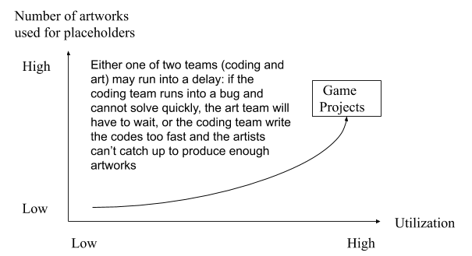

Our utilization rate will be high, but that will result in longer waiting time if a new idea arises, the levels become too easy or too hard to play or a bug that will delay the developers from reconciling with the designers.

However, in reality, creating artworks is likely to be our major bottleneck. Many game start-ups have also run into this problem before [10]. Artworks can be obtained via free assets, priced assets or self-created artworks. As such, we have to limit using available assets to make our game unique. To draw out and design refreshing game characters, there will be much efforts involved and the environment background must fit in with the game style. Therefore, artworks and level design are mostly likely to be the major obstacle that slows down the process.

# III. Materials, production flows and waste

## 1. Material flows & facilities

### a. Type of layout in our production system

**-** The “Kivapeli” way: we will utilize the functional layout for our production system. The advantage of this layout is the specialization of our team members to focus on their specific tasks. Since we aim at a cross-functional development team in each team, this layout is well suited for us.

At this point, we appoint a new person as the product owner/project manager. In our project, there are three permanent teams: programming team (4 members), art team (4 members) and design team (2 members), and two third-party commissioned teams: music/sound production team and game testing team.

+ Product manager: Responsible for the product backlog and enhancing the multi-tasking between different teams. When the game is launched, he will market this game to potential players.

+ Design Team: Responsible for concept art, character design, environment design and visual effects.

+ Art Team: Based on the sketch of the design team, the art team delivers the final version of the concept

+ Programming Team: Responsible for GUI implementation, coding for interactions between characters and environments and examining logic algorithm.

+ Game testers: Responsible for finding potential bugs in the game, giving feedback as a player if the game is engaging and ensuring consistency within gameplay.

+ Music/sound producers: responsible for voice acting and background music. They should work closely with our art team to synchronize the theme of the gameplay.

- Cross-functional development: Some of these specialized works above may need unanimity among several teams to move on. For example, the character design is exclusively the work of the art/design team. However, the programming team will collaborate with the art team on the design (movement, appearance) so their work can be synchronized. For the testing part, it is exclusively the work of game testers, but the coders and will be directly responsible to fix anything in the report provided by the testers.

### b. Process steps alignment in our production system

We utilize agile development using scrums for our production process. We intend to have one sprint at most each month for 2 years, which lasts one game project. Deadline of scrums can be extended due to unpredictable work flows. The project manager will hold weekly scrums to update with upcoming tasks and finalized tasks.

**Our process consists of 6 steps:**

1. Conceptualizing idea: The project manager examines the potential and practicality of our game idea. Then the Scrum meeting is organized to sketch the basic concept of the game
2. Sprint planning and product backlog: A more specific planning of the product is discussed and visualized. Then the Scrum board will be updated with a list of tasks: how many arts should be finished within the given time, how much in-game dialogues are composed and how much codes the developers must complete.
3. Sprint: (2-4 weeks) This is where most of the programming and designing take place. By pair programming, the team tries to fasten this process with better quality: cleaner code, better diffusion of knowledge and reduction in coordination efforts [11] So each two coders work in a pair and there are two pairs. A daily Scrum review is organized to check daily progress and discuss any existing obstacle.
4. Testing and game’s progress increment: The two parts test out the game’s functionality and quality. The first is to check if the game works as intended. The latter is a quality control meeting with the product owner.
5. Sprint backlog and retrospective: This is where each Scrum team review their last Sprint, fix the existing problems and find a way to become more productive after each Sprint. After each sprint, members should be aware of the path that the game is heading towards, because risks always exist. Deliverables from each sprint may receive feedback from game testers.
6. Pre-launch and release: When the game passes the function and quality test, a limited beta edition will be published. Feedbacks from game testers will be discussed in the last Sprint planning, which aims to finalize the product and release the official game

### c. Process flow chart

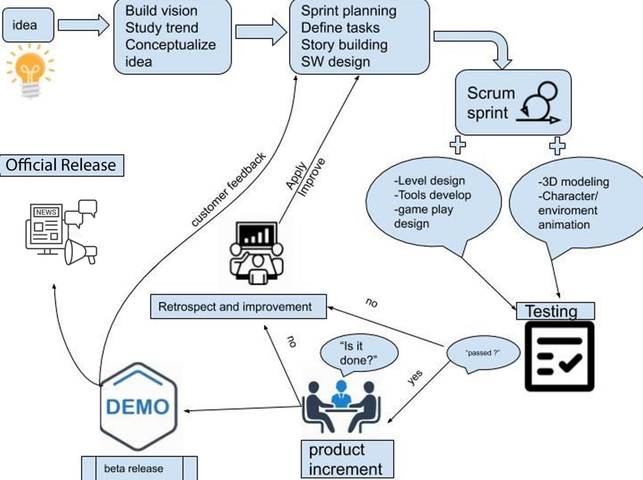

## 2. production flow

### a. Push or pull control?

Our production system utilizes Push control with Scrum framework: We create games that meet the customer's demands by studying gaming market and gaming trends => Our game development is offered to potential players by pushing our “games” to attract their interest.

### b. Throughput time and flow efficiency

**Throughput time: [12]**



Our flow units are one game title. The through put time to produce a complete game from start to finish is:  
+ Processing time = Ideas & visions time + Core Game development time = 2 months + 17 months = 20 months  
+ Inspection time = Test time + Fixing bugs time = 4 months  
+ Move time = Uploading onto public applications time = 0.5 month  
+ Wait time = License approval time = 0.5 month  
Then:   
           (Estimated) Throughput time =  19 + 4 + 0.5 + 0.5 = 24 months = 2 years

**Flow efficiency: [12]**

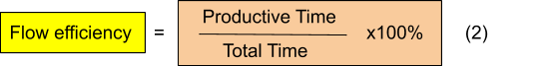

For each day, we work on the project for around 7 hours. However, we will take one day off in Sunday, which means that total productive time for each week is 7 x 6 = 42 hours. The total hours of a week is 24 x 7 = 168 hours  
Then:  
            (Estimated) Flow efficiency each week = 42/168 x 100% = 25%

We have one sprint each month, as each game lasts 2 years, there are estimated to be 24 sprints. At the end of each month we take 2 days off. Supposed each month has 30 days (4 weeks and two days). We will have five days off each month and work 7 hours for the rest 25 days, so productive time each sprint is 25 x 7 = 175 hours and total time for each sprint is 24 x 30 = 720 hours.   
Then   
 (Estimated) Flow efficiency each sprint = 175/720 x 100% = 23,8%

- Since our Gaming start-up begins with 10 people and one project manager, we can communicate and complete projects together, there’ll be little wasted time for reporting (only 15 minutes for Daily Scrum), formal meetings and procedures so our estimated flow efficiency is maintained not lowered than 23%.  
- Our flow units: game titles  
- Our main Resource is human resource: each of the members follow the Scrum framework to reach our best performances and optimize the development process.

## 3. Minimizing waste

### a. Deviation of quality

**-** Problems will arise when the beta version is finished and tested. Deviations of quality occur as the game does not respond to what coders intend (bugs) and the levels are unexpectedly too easy/difficult or lacking fun and exciting visual elements. [13]

**=> Requirements for our technical quality control:**+ Small Q: The game must work as intended by the developers.  
+ Big Q: The players must find the game enjoyable and engaging

### b. Ways to reduce deviation of quality

For game testing, we will commission a third party to test our games in many rounds in the beta release. The game testers will be responsible for quality assurance of our game.

- In-Game Interactions: As game-testers progress through the games, they will investigate whether the game behaves as intended (for example, the characters can fall out of the “world” or they go pass through trees). They will examine if moves of characters deviate from what developers expect, and whether the buttons in-game work smoothly. Common cause is wrong syntax in the code and specific cause is wrong logic in the code implementation.

=> Game testers will note all bugs for quality management report in the final sprint retrospectives. The coders will be responsible for fixing these bugs.

-  Level design: Our game will have different story modes and 3 levels of difficulty. Game testers will play through each mode and difficulty level and report these criteria:

+ Quality: Although the game may appear interesting to our teams, outside perspective will be more objective => The game testers will report our teams for us to make sure the game is fun and engaging. The specific cause is that team members will not detect something wrong because they are not players.

+ Difficulty: the difficulties (puzzles) may be inconsistent with what our teams expect. If these inconsistencies arise, we will readjust the content to match the expectations of players.

- Game testers will add these problems to their quality assurance report so our teams can improve them before the official release

### c. Minimizing waste

According to TPS, our potential wastes in game development are:

+ Waiting: Our bottleneck is mainly concerning artworks. It is expected that the code team will progress much faster than the art team. Since our goal is “quality-focused”, high-quality artworks are the crucial components to the players’ experience.

=> To solve this waiting waste, the coders will use “placeholders”: free source artworks that serve as temporary objects for coders to work. When the art team finishes the arts, the coder will swiftly replace the placeholders with these arts.

+ Extra-processing: For each sprint, our teams may overcomplicate the game design. Typically, in adventure games, players will not make unusual moves or interactions with the virtual world.

=> Our teams may agree on reducing the scale of the game design. Not all regions and features in the game need to be realized. For example, the virtual world will rotate in a loop if characters travel endlessly in one direction, or the characters can only move in 4 directions (isometric design).

**- Other techniques:**

+ Kaizen: in each sprint review, every member has to share the problems they face and what can be done to fix them, and how they can be improved. For example, coders discuss with each other how they can improve their codes, make more precise implementations that can be reapplied later. For the art team, artists should strive to improve their artwork in all possible ways (from references, from feedback of other outside artists)

+ One-piece flow: Our teams will focus on making each small puzzle/level in a scheduled order. We can only move to the next part when we finish one level/puzzle. This prevents us from wandering far away from the current project.

# IV. Operations, procurement, supply chain & demand Assessment

## 1. Focus of operations & procurement

### a. Core capabilities

Our company’s core capabilities are

+ Artworks: It represents our value proposition (delivering high-quality, immersive experience) which is crucial to the gamers. We believe we excel in drawing high-end and vector artworks better than other start-up studios.

+ Game design: It represents the soul of our games (engaging gameplay with unforgettable memories) that creates a great impression on players. Our level design, concept art and in-game monologues will be a unique combination that has not been conceived before (similar game design to other games can be sued due to plagiarism)

### b. Outsourced activities

Base on Kraljic matrix, we focus outsourced procurement on:

1. Audio soundtrack: Because we do not have a specialized audio team but audio is an essential part of our product, we will outsource this work to an experienced music production team/individual (example: Chipzel, Waterflame, Magnus Palsson). The music will deliver the best experience that helps us stand out from other game start-ups.
2. Game testing: When our Alpha version is completed, a different viewpoint from a professional game tester will have special benefits regarding game interaction, degree of perfection and errors for us to debug and polish the game to reach its final version.
3. Merchandising: If our game gains some popularity in the future, there will be a need to advertise our games on a greater scale, such as forming relationships with toy companies, other game studios and advertisers. We’ll hire a commercial team to bring our games to every potential player.

### c. Procurement

**Direct procurement** (Audio soundtrack, Game testing): We’ll create a recruitment process: we look for profiles on websites such as LinkedIn, Twitter, Gamedevmap, Gamasutra and Game Recruiter; we interview the capable editors and testers; we agree on salaries, then sign contracts with them.

**Indirect Procurement (**Merchandising**):** Our commercial team may contact big brands like Lego, Nintendo, and Mattel to deal on producing toys inspired from our games; social media like Facebook, YouTube, and Instagram to advertise our products; other popular games studios to potentially learn from their experience.

One important resource to run our gaming company is electricity. It is not strategically important but tremendously affects our operation. We plan to purchase a power generator from Generac Holdings Inc., in case there are power outages or natural accidents.

According to our Porter's Five Forces analysis, there are a lot of entrants into game development in the Finnish market. It will certainly be challenging to find and keep well-suited, experienced staff loyal to our company, since there are many other start-up studios as well. Furthermore, after a game project, we prefer the old staff to stay and sign with us another contract. The process of recruiting new members again will lower our productivity and cost us much more unnecessary expenses.

### d. Parts of our supply chain

We only have **one tier of suppliers.** They are:

+ Design Resources: the placeholder assets can be obtained from royalty free websites that coders can temporarily use in the place of the main artworks produced by the art team.

+ Programs: To develop games, we need specialized programs from various companies such as Unity (Unity Technologies), Photoshop and Illustrator (Adobe Inc.) by paying them yearly subscription. These companies provide industry-standard programs, enabling us to work at high speed and precision.

+ Equipment: We will purchase 2 PC sets from Dell and several drawing tablets from Wacom Co., Ltd. Both companies are reputed tech companies that have excellent support for their buyers.

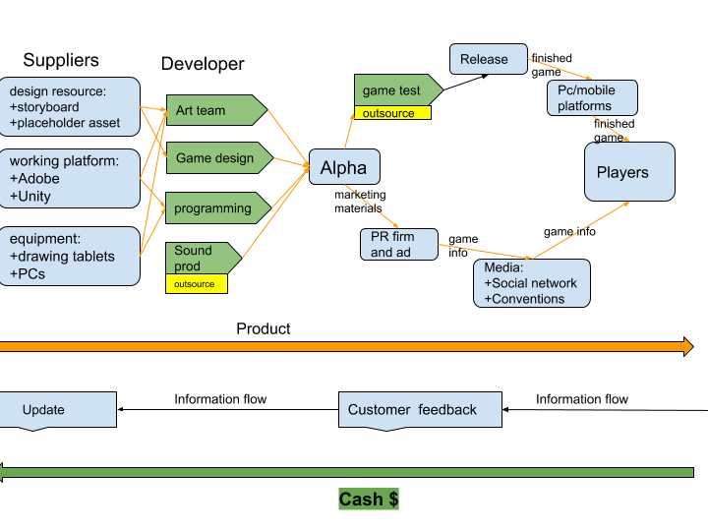

- Geography of our supply chain: all of game development activities will take place within one game studio office. The supplies will be transported right to our office. The outsourced teams (sound producers and game testers) will also work in close collaboration with our teams at our game studio. Our platforms will be online and players can play our games on mobiles of both operating system Android and IOS.

- Relationship: All of our suppliers are almost leveraged items according to the Kraljic Matrix, as these multinational companies can provide their services at any time and they have high-quality support. However, we only buy these equipments once, so there is no utilization in purchasing power in our supplies. Inside our game development, design, art, coding and music producing teams work in close proximity, enhancing coordination that improve the quality of our games.

- We reduce our launching cost by not directing our game to any publisher to be distributed. Therefore, the project manager will be responsible for marketing our games and receiving feedback from players.

## 2. Demand assessment

### a. Fluctuation in demand

- Trend fluctuation in demand: the demand for playing games gradually increases in time as the young population grows larger in developing countries. There is a surge in demand for virtual gaming as well [14].

- Seasonal fluctuation in demand: According to studies, the sales of video games are highly seasonal. It is recorded that video game spending typically reach their climax in the winter months of November and December, with monthly sales that are at least three times higher than other months of the year. In the summer, game demand is slightly higher than the spring and the autumn [15]

- Cyclical fluctuation in demand: Global recessions usually occur over a cycle lasting between eight and ten years. [16] Especially in Europe, economic crises are quite common (Great Recession 2008-2016, COVID-19 Recession 2020). Games are recession-proof or even experience rising profits because many unemployed people will stay home and resort to playing games.

- Random fluctuation in demand: In 2020, the COVID-19 pandemic broke out and imposed large-scale lockdowns around nations. People under lockdowns will obviously find many ways to entertain themselves, including spending much more time playing games or entering the gaming world. The pandemic will convert many people to game players and their gaming habit will remain even if the pandemic ends [17]

### b. Withstanding fluctuations in demand

Our forecast-driven operations are

- Information flow: the project manager and PR firm are responsible for tracking information flow from customers and activities associated with our games. They will report to the staff in time after each Scrum sprint so that everyone is updated with the demand for interactive adventure games before each quarter.

- Direction to game development: Considering that the end of the year is when the demand for games rises three times more than others, we will direct our busiest development activities in Spring and Autumn. These two months have the lowest game demand, which is an appropriate time for us to focus on game development. As winter arrives, we will release our games to maximize our profits, according to the forecast.

- Operational flexibilities: Not all teams have to work together in the office every day. We will meet together in small sessions, discussing the work that needs to be addressed. For example, the design and art team should meet together and discuss the character design. After that, the design team will discuss the game mechanics with the coders. These small sessions help us stay focused on the incomplete tasks and prevent late release of the games. After people go back to schools and to work, game profits would be greatly reduced and we would obviously want to prevent that.

### c. Demand estimation

|  |  |  |  |  |
| --- | --- | --- | --- | --- |
| Demand forecast (number of installs on Android platform) | | | | |
| Quarter | Year 1 | Year 2 | Year 3 | Year 4 |
| 1 | 75000 | 120000 | 1500000 | 2400000 |
| 2 | 75000 | 135000 |
| 3 | 75000 | 120000 |
| 4 | 225000 | 375000 |
| Total | 450000 | 750000 | 1500000 | 2400000 |
| Average | 112500 | 187500 | 375000 | 600000 |

**How demand develops over time:** As discussed above, Covid-19 and economic recession will make more people stay home. The number of converts to game will increase considerably during 2020-2021, which boosts game sales dramatically [18] Even when the pandemic ends, these game converts will maintain their gaming habit. Combined with our marketing and PR team, we expect that the demand for immersive-adventure games will increase around twice each year for the first 4 years. After that, the demand may slow down and remain constant.

**Reliability of our demand forecast**

- Qualitative: Based on three games that have similar adventure gameplay and high-quality focus like our games, namely Deep Town (Rockbite Games), LIMBO (Playdead) and Children of the Light (Thatgame company), we estimate that our games will have a total of around 5 million downloads after 4 years.

- Seasonal: It is recorded that game activities will peak around November and December - the 4th quarter, which is at least 3 times more than other quarters in the same year. The second quarter will be in the summer when students and workers have a break. Therefore, we estimate that the demand of the second quarter is relatively higher than the first quarter and third quarter.

- Causal: Currently, COVID-19 has forced people to stay under lockdown. People will find ways to entertain themselves. We estimate that the demand for interactive gameplay will soar as some people will play mobile games while quarantined.

We believe that our demand estimate is reliable because we observe the demand from previous games that are most similar to our game genre. Based on the research, we can determine what time of the year the demand for games is the highest. The demand above only takes into account the Android platform. We believe our demand is much higher if we release on IOS platform as well.

# v. Project network & risks

## 1. Project network

### a. Task Network

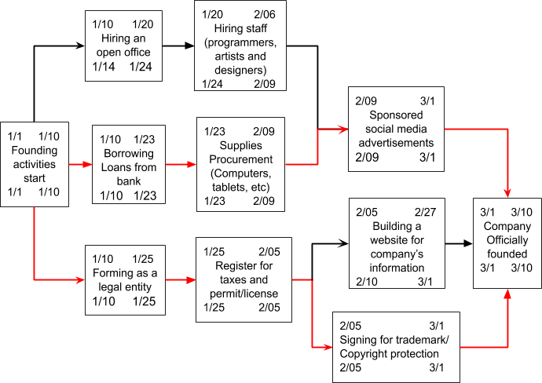

- From the start of the founding activities to the official company foundation, it will take us more than 2 months.

### b. Flexibility in our project network

There is some flexibility in our project network, namely hiring an open office, recruitment and website building:

+ Before hiring, we have to receive loans from the bank to fund our various cash-demanding tasks. Since there are always unoccupied office for rent around the Uusimaa region, we do not rush to find a workplace.

+ During the recruitment process, we are not sure if we can find the right people within the allotted time so there will be floats around 3-4 days. Recruitment is important to our company because it will define our quality delivery.

+ Obviously, a gaming company should at least have a runnable website, be it either built independently from outsourced party or a web domain on content management system such as WordPress.

### c. The critical path

There are two critical paths in our project network: legal formation and resources procurement.

+ For legal formation, we need to establish our business as a legal entity. We will decide our name as Kivapeli and register this name. The process also involves opening a bank account connected to business activities. Then we will file a notification to the Trade Register and various Tax Administration registers to declare taxation category. After that, we need to protect our intellectual properties by registering a patent at the Finnish Patent and Registration Office (PRH). This will cover everything that ensures our company’s legal foundation.

+ Resources procurement: Receiving loans from a bank is important for our early steps to fund many processes, such as hiring office, recruitment, office supplies and paperwork. After receiving loans, we will purchase working devices, such as PC sets, drawing tablets, lighting, tables, electricity generator and office tools. After this, we start to run ads on several platforms to make our existence known

## 2. risks

### a. Categories of risks

There are two types of risks for our game development: internal and external risks.

|  |  |
| --- | --- |
| **Internal risks** | **External risks** |
| + Financial risks: Profits are not high enough to be solvent at the end of the financial year.  + Business risks  - Qualifications: the recruited staff are not able to complete their assigned tasks due to lacking the necessary skills  - Management: Tasks are not completed before the latest deadlines.  - Trust: the quality of game testing done by game testers has no benchmark to rely on => we have to rely on their trustworthiness.  - Release mistiming: Releasing the game on the moment with low volume of players => Low return on revenue  + Technical risks: Server system crashing. This is caused by untested updates and unverified modifications in the game | + Pure risks such as electricity cut, working devices malfunctioning, theft, fire and regional risks such as natural disasters  + Unclear monetization motive: instead of increasing monetization, the game mechanism can unexpectedly make players unwilling/hate to make in-app purchases [19]    + New game genre: this can be either good or bad. If a new type of game arises and dominate the market, other game genre will receive less attention => Lower profitability  + Censorship: Games can be banned if it mistakenly mentions censored political theme or contain parts unsuitable for young players |

### b. Our preparation for risks

|  |  |
| --- | --- |
| **Internal risks** | **External risks** |
| + Financial risks: Cost forecast must be thorough and consult from the experience of previous failing projects due to lack of budget.  + Business risks - Qualifications: Recruits have to pass a qualification test. We will either devise this test or consult from other game projects. - Management: If the art team fails to complete the deadline on time, designers can aid the artists in minor image manipulation and lighting. - Trust: We will ask normal, inexperienced players to play the game. This is how our game may actually receive feedback from players  - Release mistiming: we will rely on demand forecasting to predict when the volume of players reaching their maximum and then release our games.  + Technical risks: Before updating, the examination must be made by all four game developers that every modification leaves no place for errors. | + Pure risks: we would buy an electricity generator in case of power cutdown. If devices malfunction, if warranty hasn’t expired, we will contact the provider. We also buy insurances in case natural disasters take place.  + Unclear monetization motive: we will not make constant pop-ups that urge players to make in-app purchases. We will make some resources rare and players can voluntarily access the stores to buy the resources.  + New game genre: If this happens, we will try to penetrate into the market of this new genre before too many entrants make the market saturated.  + Censorship: Our games are based on the country’s history and fantasies. We will make sure that our game contains limited religious themes and neutral political theme. |

# vI. financial statements

## 1. Financial statements

This part is in the Excel file

## 2. Assessment of profitability, liquidity and solvency

The indicators’ calculations of Kivapeli Game Studio and those of our competitors can be found in the excel file. Generally speaking, we operate at a much smaller scale than our competitors, since we are just a new start-up. In general, we estimate that we have higher indicators of profitability and liquidity and lower solvency than our competitors Rovio and Remedy

+ Profitability: we believe that we don’t have M&A and investing activities so our operating income can be lowered, thus increasing our operating income and subsequently raising our profit margins. Other larger, AAA-type game companies may spend a large portion of income into various activities so we expect that their profit margins will not be as high as ours. Our return on equity and return on assets are quite high, because our capital is quite small compared to the profits. For the first two year, profits make up large portions of our assets. However, by not investing to expand our company, we cannot enlarge our scope and thus always remain small-scale. Large game companies may have lower profit margins, but they can expand their company with their great equity, thus increasing the scope of their revenues.

+ Liquidity: We have slightly higher liquidity than Remedy but lower than Rovio, which means that we are able to repay our debt in time because we have relatively high equity compared to debt. However, as stated in our balance sheet, we have no account payables, so there is no need to pay short-term debt. For the loans from financial institutions, we borrow at the end of 1st year to run our operating activities. As soon as we have received our profits, we immediately pay back the loan in full at the end of 2nd year to prevent incurring interest expense. For our competitors, they also have a high current ratio. This is understandable, but unlike our company, they have many short-term debts that they must pay frequently as long as periodic payment of long-term loans.

+ Solvency: we have debt to equity ratio and debt to assets ratio equal to those of Rovio and lower to those of Remedy. For start-up, this figure is a considerably positive sign, because gaming start-up usually experience negative assets. Another reason for this is that we may have overestimated our profits. If our profits turn out to be much lower, our solvency can be higher. For large businesses that have long-standing foundations such as Rovio, EA and Remedy, a solvency of more than 20% but not more than 40% is an ideal range. Therefore, we believe we are heading in the right direction of balancing between our liabilities and equity.

## 3. investments

This part is in the Excel file

# VII. References

[1] Gaming Market - Growth, Trends, Forecasts (2020 - 2025). Available at <https://www.mordorintelligence.com/industry-reports/global-games-market>. (Accessed Sep. 20th 2020)

[2] Chapple, C. (Sep 14th, 2020). Top Mobile Games by Worldwide Revenue for August 2020. Available at <https://sensortower.com/blog/top-mobile-games-by-worldwide-revenue-august-2020> (Accessed Sep. 20th 2020)

[3] Ernst & Young Oy, M. R. (February 11th, 2020). Annual Report, Espoo: Authorised Public Accountant firm, Authorised Public Accountant.

[4] Interesting facts about Rovio, retrieved from https://videogamesstats.com/Publisher/rovio-entertainment/ (Accessed Sep. 20th 2020)

[5] Products, Simcity BuildIt. Available at https://sensortower.com/ios/us/electronic-arts/app/simcity-buildit/913292932/overview (Accessed Sep. 20th 2020)

[6] Anon. (2006). *Video Game Background*. Available at <http://www.madehow.com/Volume-5/Video-Game.html> (Accessed Oct 3rd 2020)

[7] Stefyn, N. (October 24, 2019). *How Video Games Are Made: The Game Development Process*. Available at [https://www.cgspectrum.com/blog/game-development-process (Accessed Oct. 3rd 2020)](https://www.cgspectrum.com/blog/game-development-process%20(Accessed%20Oct.%203rd%202020))[8] Brice, A.(n.d). *Successful Software*. Available at <https://successfulsoftware.net/2017/02/10/how-much-code-can-a-coder-code/> (Accessed Oct. 3rd 2020)

[9] Horton, A (August 19, 2017). *How much does it cost to run a game server?,* Available at <https://www.servermania.com/kb/articles/how-much-does-it-cost-to-run-a-game-server/> (Accessed Oct. 3rd 2020)

[10] Doucet, L (06/20/16). *Bounds, Bottlenecks, and Digital Marketing.* Available at <https://www.gamasutra.com/blogs/LarsDoucet/20160620/275369/Bounds_Bottlenecks_and_Digital_Marketing.php> (Accessed Oct. 3rd 2020)

[11]. Pair Programming, *Agile Alliance*. Available at <https://www.agilealliance.org/glossary/pairing/#q=~> (Accessed Oct. 11th 2020)

[12] Kanbanize, n.d. *Monitoring Flow Efficiency.* Available at <https://kanbanize.com/kanban-resources/kanban-analytics/flow-efficiency> (Accessed Oct. 11th 2020)

[13] Ucas (n.d). *COMPUTER GAMES TESTER.* Available at [https://www.ucas.com/ucas/after-gcses/find-career-ideas/explore-jobs/job-profile/computer-games-tester (Accessed Oct. 11th 2020)](https://www.ucas.com/ucas/after-gcses/find-career-ideas/explore-jobs/job-profile/computer-games-tester%20(Accessed%20Oct.%2011th%202020))

[14] Rogoff, K. (April 5, 2002) The Recession that Almost Was. Available at <https://www.grandviewresearch.com/industry-analysis/virtual-reality-in-gaming-market#:~:text=The%20global%20virtual%20reality%20in,take%20gamers%20into%20their%20screens>. (Accessed Oct. 12th 2020)

[15] Anonymous (Jun, 2020) Virtual Reality In Gaming Market Size, Share & Trends Report. Available at <https://www.statista.com/chart/16211/monthly-video-game-industry-sales/>  (Accessed Oct. 12th 2020)

[16] Richter, F. (Nov 29, 2019) Video Game Sales Are Extremely Seasonal. Available at <https://www.imf.org/en/News/Articles/2015/09/28/04/54/vc040502>  (Accessed Oct. 12th 2020)

[17] Epstein, A. (September 17, 2020) The pandemic has turned everyone into gamers. Available at <https://qz.com/1904276/everyone-is-playing-video-games-during-the-pandemic/> (Accessed Oct. 12th 2020)

[18] Smith, N. (May 13, 2020) The giants of the video game industry have thrived in the pandemic. Can the success continue? Available at <https://www.washingtonpost.com/video-games/2020/05/12/video-game-industry-coronavirus/>  (Accessed Oct. 12th 2020)

[19] Leonard, P. (April 23, 2019). Risk Management: What, Why and How. Available at   <http://leonardperez.net/risk-management-what-why-and-how/> (Accessed Oct. 12th 2020)